**Exercise 1: Create a Scalar Function**

Goal: Create a scalar function to calculate the annual salary of an employee.

Steps:

1. Define a scalar function named `fn_CalculateAnnualSalary`.

2. The function should take `Salary` as input and return `Salary * 12`.

3. Test the function by selecting the annual salary for each employee

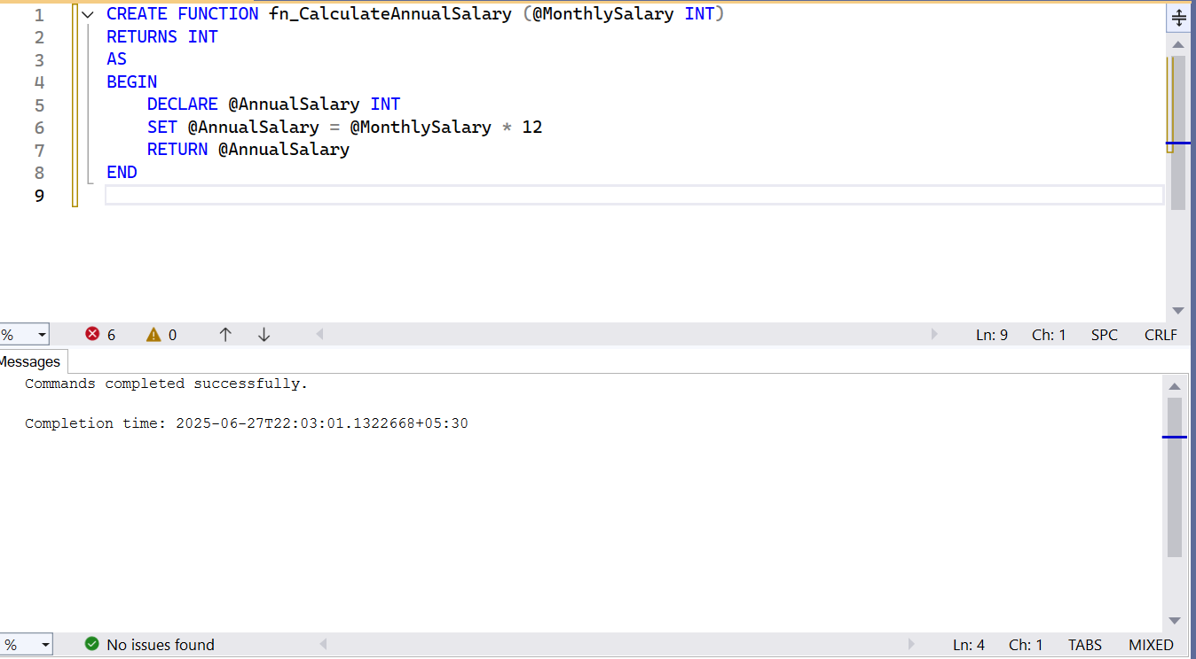

**Exercise 2: Create a Table-Valued Function**

Goal: Create a table-valued function to return employees in a specific department.

Steps:

1. Define a table-valued function named `fn_GetEmployeesByDepartment`.

2. The function should take `DepartmentID` as input and return a table with employee

details.

3. Test the function by selecting employees from the IT department

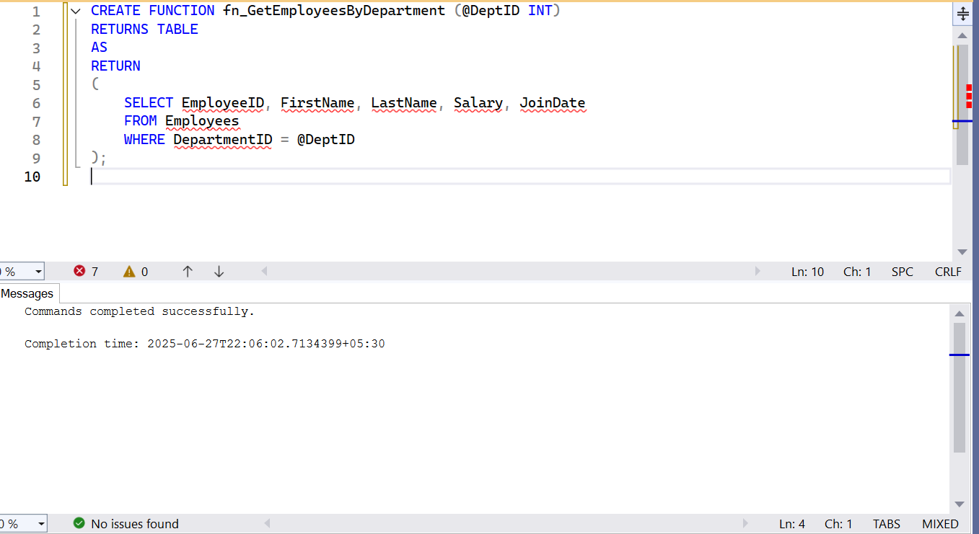

**Exercise 3: Create a User-Defined Function**

Goal: Create a user-defined function to calculate the bonus for an employee.

Steps:

1. Define a user-defined function named `fn_CalculateBonus`.

2. The function should take `Salary` as input and return `Salary * 0.10`.

3. Test the function by selecting the bonus for each employee.

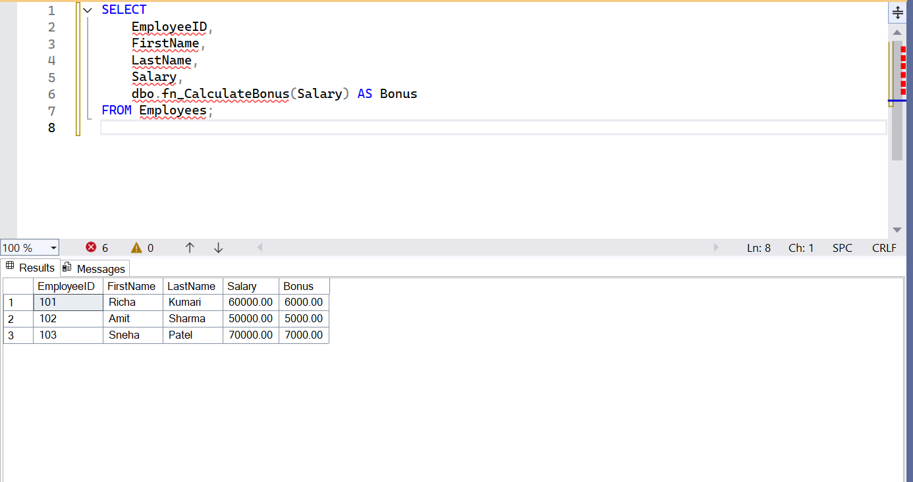

**Exercise 4: Modify a User-Defined Function**

Goal: Modify the `fn_CalculateBonus` function to return `Salary * 0.15`.

Steps:

1. Alter the `fn_CalculateBonus` function to return `Salary * 0.15`.

2. Test the modified function by selecting the bonus for each employee.

